 | Year 11 Methods  Week 3 Quiz | $$\frac{}{16}$$

Name: __________________
1. | Which statement is true?  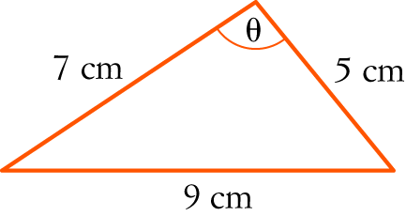  A cos (θ) = B cos (θ) = C cos (θ) =  D cos (θ) = E cos (θ) = | 1
2. | Which statement is NOT true?  A sin (180° − x) = sin (x) B sin (2π − x) = −sin (x) C sin (2π + x) = sin (x)  D sin (−x) = sin (x) E sin (180° + x) = −sin (x) | 1
3. | tan =  A B C D E 1 | 1
4. | Convert the following to degrees.  a  b  c  d | 4
5. | Evaluate x correct to one decimal place.  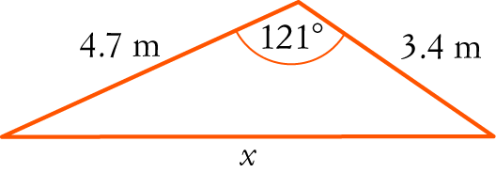 | 3
6. | A sector is cut off by an angle of subtended at the centre of a circle with radius 8.6 cm.  a Find the length of the arc cut off by this angle.  b Find the area of the sector. | 4
7. | Which degree is at point (-1, 0) ? | 1
8. | For which two angles is cosθ = ½ ? | 1

